[Enter Program Name] Designated Individual Orientation

Program Goals
Consider the purpose of your program and what campers will take away from their experience (remove this line)
- Purpose of the program: [Input the purpose of the program]
- Expected learning outcomes: Campers at [insert program name] can expect to [insert learning outcomes]
- Key Camp Contacts and Phone Numbers:
  - [Insert important contact information here]

Designated Individual Responsibilities
Designated Individual Role
- Role: Explain what their role is in the program
Arrival/Departure Times:
- Designated individuals should arrive at [location] at [time] and depart at [time]
- [insert the program’s time off policies]
- [insert the program’s sick policies]
Parking:
- Designated individuals will park at [insert garages or parking lots]
- Include information about if the program provides parking vouchers
Camper Orientation
- [Insert when/where the orientation will be held and a brief description about the content involved]
Check-in/Check-out
- [insert the program’s check-in/check-out policy and procedures
- Designated individuals must verify the driver’s license for parent drop-off/pick-up
- If applicable, make sure to include information regarding the Attendance sheet (found in Ideal Logic) for campers who can self-check-in/check-out, or those campers who have permission to bus/bike/fly/drive
Breaks and Lunch Breaks
- Campers must still be supervised during breaks
- [insert information here about the length of breaks and lunch breaks]
Dress Code
- Appropriate Attire: [insert appropriate attire for the program]
- Inappropriate Attire: [insert inappropriate attire for the program]
Designated Individual Duties
- Designated individuals are responsible for ensuring the safety of each camper
- Follow instructions from the camp director and execute or implement the program’s supervision and instruction plan.
- Monitor the behavior of campers to ensure that they adhere to the program’s code of conduct
- Enforce rules and immediately communicate any issues that occur to the camp director
- Mandatory reporters/reporting: All camp directors and designated individuals must report to DFPS if they believe a child is being abused or neglected.
- [Include any other additional duties relevant to the program]
Designated Individual Attitude
- Maintain a professional demeanor at all times with campers
- Have a cordial, helpful, friendly attitude
- Be aware of all prohibited conduct rules (presented in the next section)

Prohibited Conduct
- THERE IS A ZERO TOLERANCE POLICY FOR DRUGS/ALCOHOL OR TOBACCO
- Examples of appropriate and inappropriate interactions between campers and designated individuals are listed below

Appropriate Physical Interactions
- Side hugs
- Shoulder-to-shoulder hugs
- Pats on the shoulder or back
- Handshakes
- High-fives and hand slapping
- Verbal praise
- Pats on the head (when culturally appropriate)
- Holding hands (with young children in escorting situations
Inappropriate Physical Interactions
- Full-frontal hugs
- Kisses
- Lap sitting
- Wrestling
- Piggyback rides
- Tickling
- Allowing a camper to cling to a designated individual’s leg
- Massaging of any kind given by or to a youth
- Compliments relating to physique or body development
- Touching the bottom, chest, or genital areas
Appropriate Verbal Interactions
- Positive reinforcement
- Appropriate jokes
- Encouragement
- Praise
Inappropriate Verbal Interactions
- Name-calling
- Discussing sexual encounters
- Secrets
- Cursing
- Off-color or sexual jokes
- Shaming
- Belittling
- Derogatory remarks
- Harsh Language that may frighten, threaten or humiliate campers
- Derogatory remarks about the camper or their family

Social Media Protocols
- All social media profiles must be set to private during the duration of the program
- Do not friend/follow campers on social media, including gaming platforms or video games
- Campers cannot friend/follow designated individuals on social media, including gaming platforms or video games
- Designated individuals are only allowed to communicate through the program’s social media group accounts
- Do not communicate with campers after the program has ended
Media Protocols
- Designated individuals are not allowed to take pictures or videos of campers on their personal cell phones
- Programs must utilize a program cell phone or camera
- Program photos may be posted on the program’s text page
- Designated individuals are not allowed to post pictures, videos, or social media accounts of any camper
- The University of Texas at Austin does not cover designated individuals under the Media Consent Form

Supervision
Camper Supervision
- YPP Rule of Three:
  - Campers should not be alone with a designated individual outside the presence of others
  - Two designated individuals to every one camper
  - Two campers to every one designated individual
- There is no unsupervised free time
  - This includes breakfast/lunch/dinner breaks
  - If the program is on campus, this includes Trips to the Drag/Store/etc, exploring campus, and common areas
- Curfew:
  - [Insert curfew information here]
- Restroom Breaks:
  - Ensure campers know where the restrooms are located
  - [Insert if campers are under the age of 11: Restroom breaks must be supervised. Campers under the age of 11 are not permitted to use the restroom without supervision.]
  - [Insert if campers are over the age of 11: Campers over the age of 11 are permitted to use the restroom without supervision. However, after 5 minutes have passed, designated individuals should go to the restroom and check if the camper is okay.]
- Traveling with Minors
  - Be mindful of pedestrian safety
  - Stay on sidewalks, use crosswalks, and look both ways when crossing the street
  - Designated individuals should be interspersed throughout the group to ensure campers are safe
Headcounts
- When traveling from place to place, designated individuals should complete an initial headcount and another headcount upon arrival
- Divide campers into small groups and use the buddy system
- Ensure groups are within the approved ratios
Supervision Ratio
Camper Age | Number Staff | Overnight Campers | Day-only Campers
5 years and younger | 1 | 5 | 6
6-8 years | 1 | 6 | 8
9-14 years | 1 | 8 | 10
15-18 years | 1 | 10 | 12

See Something, Say Something!
- Do not wait until something happens before saying something
- Designated individuals should communicate with campers regularly. Tell the campers to communicate with you, the camp director, or the Youth Protection Program to report anything that makes them feel unsafe or uncomfortable
- Camp directors should rehearse interrupting inappropriate behavior with designated individuals

Camper Behavior Management
Camper Code of Conduct
- [Insert the camper code of conduct]
Incident Forms
- When is it appropriate to complete an incident report form?
  - All incidents of illness
  - Medical accidents/injury
  - Code of conduct violations
  - Suspected abuse and neglect to the Department of Family and Protective Services
- Reminder: All camp directors and designated individuals are mandatory reporters. They must report to DFPS if they believe a child is being abused or neglected.
Camper Behavioral Issues
- When dealing with camper behavior, adhere to the following guidelines:
  - Be fair
  - Give a verbal warning
  - Do not admonish the whole group
  - Mediate the conflict between campers
  - Be aware of boundaries and prohibited methods of discipline
  - Always be present
  - Positive reinforcement

Bullying
- Designated individuals should reiterate the following to campers:
  - Bullying is not acceptable and will not be tolerated
  - Ask a designated individual or camp director for help if a bully bothers you
  - Report bullying when you see and hear about it. Telling is not tattling.
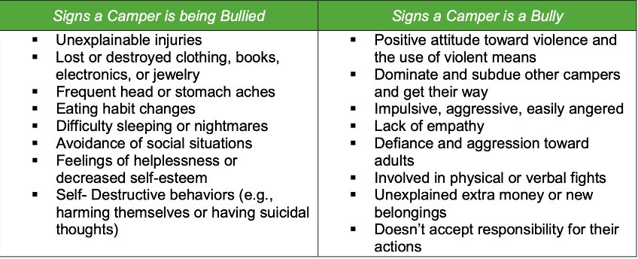
Youth-to-Youth Abuse Signs
- Youth-to-Youth abuse occurs when a child or youth (minor) is abused by another child/ren/youth (minor). The victim and the perpetrator can be of the same sex, different sexes, the same age, or different ages.
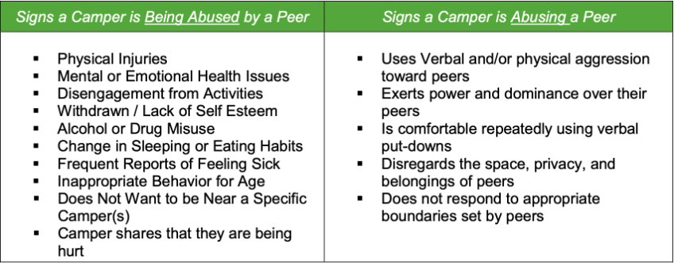
Youth-to-Youth Abuse Prevention Guidelines
- Remember that your role is supervision and not merely participating for fun
- Make sure that the ratio of staff to campers does not drop below the YPP ratio requirement, even when someone should be called away or needs to leave the site.
- Position yourself in the best spot to supervise campers. You should be able to visually observe the campers and listen to any verbal comments.

Medication Policy
Medication
Only include this section if the program distributes medication (remove this line)
- Medication policy
  - Prescription and over-the-counter medication will be given to the camp director upon arrival.
  - Medication should be labeled and placed in a bag with the camper’s name and instructions (dosage amount and times)
  - Medication must remain in the original container from the pharmacy
  - Medications must be stored and locked up
  - Two designated individuals are responsible for dispensing medications (should be named or pointed out)
  - Inhalers and EPI-Pens are allowed to stay with campers

Emergencies
Emergency Plan
- Practice the YPP-approved Program Emergency Plan
- [Insert the YPP-approved Program Emergency Plan here]
Be sure to include information about emergency response tasks, the emergency alarm device (including how many times it will be sounded), assembly areas, fire escape routes, and shelter-in-place procedures for inclement weather.
- During an emergency, remain calm and maintain order:
  - Think safety first
  - Account for all campers
  - The first-aid kit is located [insert location]
  - [insert which designated individuals can administer first-aid/CPR/AED]
- Calling 911, UTPD, or taking a camper to UHS (or other medical facility):
  - [Insert when to do so]
  - Designated individuals cannot transport minors in their personal vehicle
  - The camp director and at least 1 designated individual must remain with the camper at the hospital or urgent care.
Missing/Lost Camper Procedure
- Practice the missing/lost camper procedure:
[Insert the program’s missing/lost camper procedure here]

General Guidelines:
- Designated individuals must account for campers at all times.
- Regularly check attendance/specifically when campers are in transition
- Immediately notify the camp director if a camper is unaccounted for
- The camp director and designated individuals will immediately search the area where the camper was last seen.
- If the camper is not located, take the following actions
  - The camp director will call UTPD and wait for them to arrive
  - The camp director will contact the YPP Director
  - The camp director will contact the parents
  - Camp directors and designated individuals will continue searching until the police arrive

